Closed Boundary
# Source: AI Source: Provided by: [Data Path: Persons Table -> ID Column: 1, Name_En Column: Motasem Essam] -> From: [ChatGPT] on [7/25/2026]
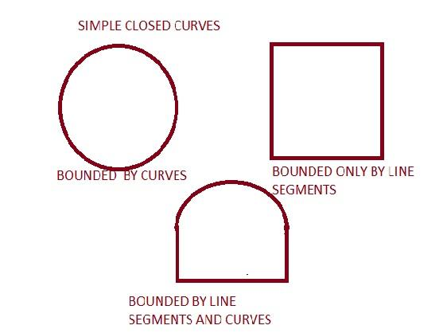
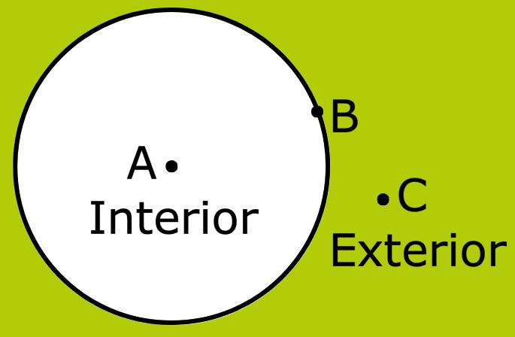
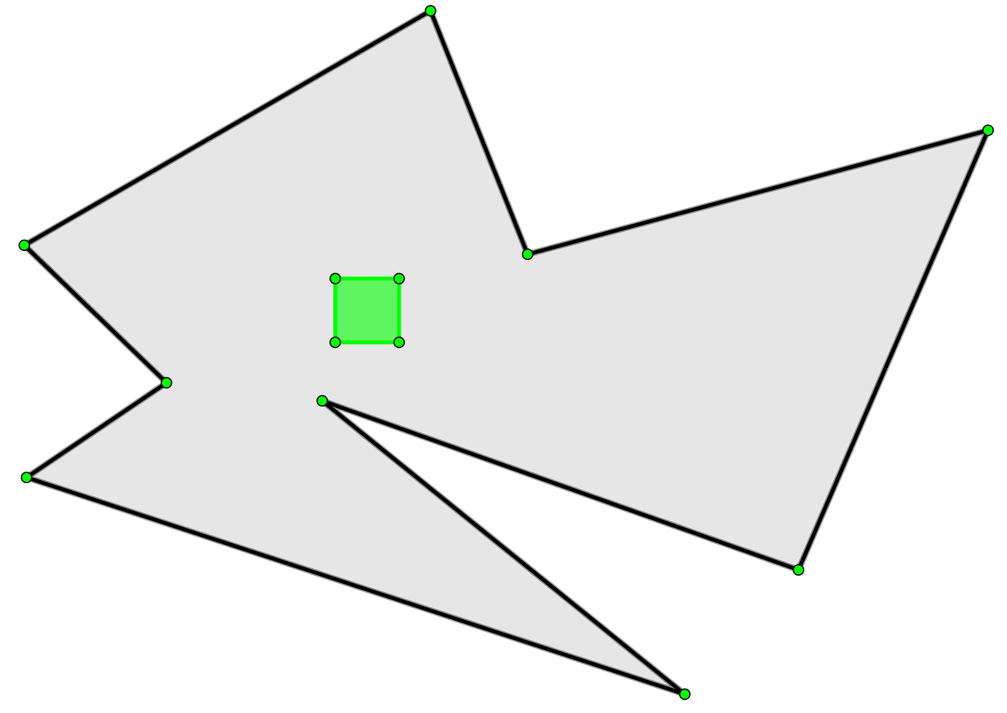
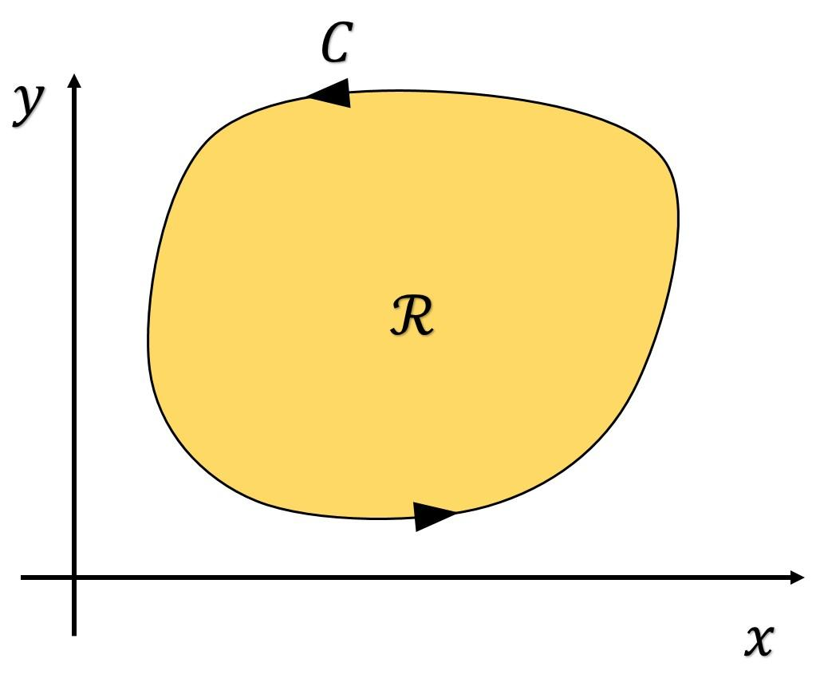
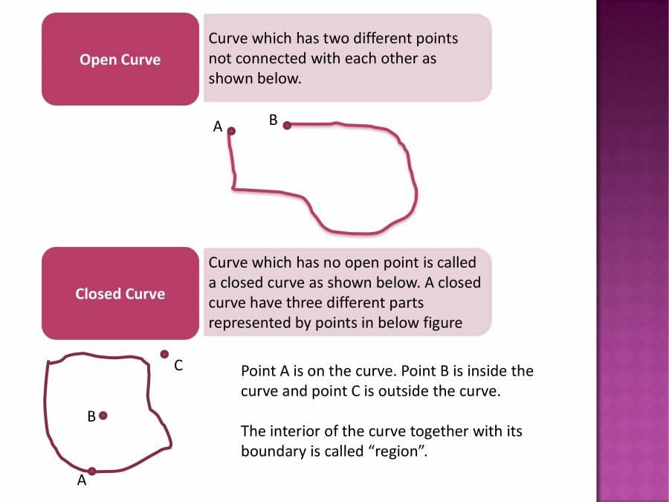
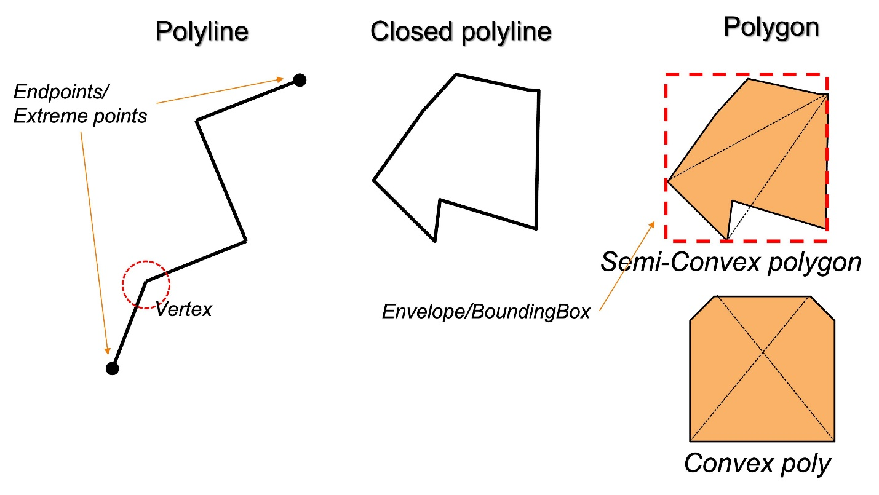

Definition
# Source: AI Source: Provided by: [Data Path: Persons Table -> ID Column: 1, Name_En Column: Motasem Essam] -> From: [ChatGPT] on [7/25/2026]
A Closed Boundary is a boundary that forms a complete loop with no openings, enclosing a region completely. Every point on the boundary is connected so that one can travel around it continuously and return to the starting point without lifting a pencil.
A closed boundary separates:
- An interior region
- An exterior region

Characteristics
# Source: AI Source: Provided by: [Data Path: Persons Table -> ID Column: 1, Name_En Column: Motasem Essam] -> From: [ChatGPT] on [7/25/2026]
A closed boundary:
- Forms a complete enclosure.
- Has no gaps or open ends.
- Separates the interior from the exterior.
- Can consist of straight lines, curves, or both.
- Encloses a bounded region.
- May have regular or irregular shapes.

Illustration

Closed Rectangular Boundary
# Source: AI Source: Provided by: [Data Path: Persons Table -> ID Column: 1, Name_En Column: Motasem Essam] -> From: [ChatGPT] on [7/25/2026]
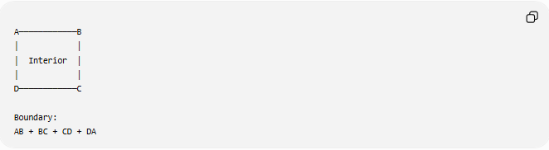
A────────────B
│ │
│ Interior │
│ │
D────────────C

Boundary:
AB + BC + CD + DA
The rectangle forms a continuous closed boundary.

Closed Circular Boundary
# Source: AI Source: Provided by: [Data Path: Persons Table -> ID Column: 1, Name_En Column: Motasem Essam] -> From: [ChatGPT] on [7/25/2026]
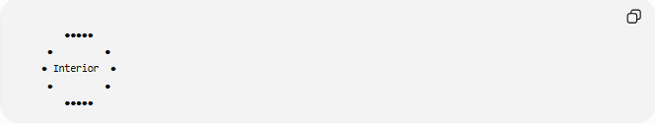
●●●●●
● ●
● Interior ●
● ●
●●●●●
The circumference forms a closed boundary.

Mathematical Representation
# Source: AI Source: Provided by: [Data Path: Persons Table -> ID Column: 1, Name_En Column: Motasem Essam] -> From: [ChatGPT] on [7/25/2026]
If:
$$R$$
is a region, its boundary is denoted by:
$$∂R$$
For a closed figure:
- Interior:
$$\operatorname{Int}\left(R\right)$$
- Boundary:
$$∂R$$
- Exterior:
All remaining points in the plane.

Examples
# Source: AI Source: Provided by: [Data Path: Persons Table -> ID Column: 1, Name_En Column: Motasem Essam] -> From: [ChatGPT] on [7/25/2026]
Example 1 – Triangle
A triangle has:
- Three connected line segments.
- One closed boundary.
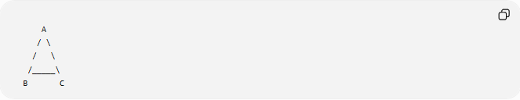
A
/ \
/ \
/_____\
B C

Example 2 – Rectangle
The four connected sides form one closed boundary.

Example 3 – Circle
The circumference is a closed curve.

Example 4 – Polygon
Every polygon has a closed boundary formed by its edges.

Properties
# Source: AI Source: Provided by: [Data Path: Persons Table -> ID Column: 1, Name_En Column: Motasem Essam] -> From: [ChatGPT] on [7/25/2026]
1. Encloses a Region
A closed boundary always surrounds a bounded region.

2. Continuous
There are no breaks.

3. Separates Interior and Exterior
Every point is either:
- Inside.
- On the boundary.
- Outside.

4. Finite Length
Although enclosing an area, the boundary itself has only length (perimeter or circumference), not area.

Closed Boundary and Perimeter
# Source: AI Source: Provided by: [Data Path: Persons Table -> ID Column: 1, Name_En Column: Motasem Essam] -> From: [ChatGPT] on [7/25/2026]
The perimeter is the total length of a closed boundary.
Examples:
Rectangle:
$$P=2\left(l+w\right)$$
Square:
$$P=4s$$
Circle:
$$C=2πr$$

Real-World Examples
# Source: AI Source: Provided by: [Data Path: Persons Table -> ID Column: 1, Name_En Column: Motasem Essam] -> From: [ChatGPT] on [7/25/2026]
Closed boundaries include:
- Property fences.
- Room walls.
- Swimming pools.
- Football fields.
- Garden borders.
- Building outlines.
- Country borders (on maps).
- Race tracks.

Applications
# Source: AI Source: Provided by: [Data Path: Persons Table -> ID Column: 1, Name_En Column: Motasem Essam] -> From: [ChatGPT] on [7/25/2026]
Closed boundaries are used in:
- Plane Geometry
- Coordinate Geometry
- Analytic Geometry
- Topology
- Architecture
- Engineering
- Surveying
- GIS (Geographic Information Systems)
- CAD (Computer-Aided Design)
- Computer Graphics

Advantages
# Source: AI Source: Provided by: [Data Path: Persons Table -> ID Column: 1, Name_En Column: Motasem Essam] -> From: [ChatGPT] on [7/25/2026]
Studying closed boundaries helps to:
- Define enclosed regions.
- Compute perimeter.
- Compute enclosed area.
- Separate interior from exterior.
- Analyze geometric figures.

Limitations
# Source: AI Source: Provided by: [Data Path: Persons Table -> ID Column: 1, Name_En Column: Motasem Essam] -> From: [ChatGPT] on [7/25/2026]
A closed boundary:
- Must have no openings.
- Does not itself have area.
- Can become difficult to describe algebraically if highly irregular.

Comparison with Other Boundary Types
# Source: AI Source: Provided by: [Data Path: Persons Table -> ID Column: 1, Name_En Column: Motasem Essam] -> From: [ChatGPT] on [7/25/2026]
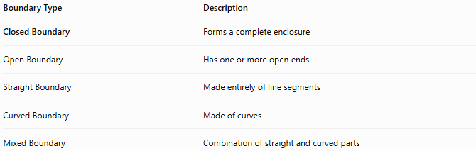
Boundary Type | Description
Closed Boundary | Forms a complete enclosure
Open Boundary | Has one or more open ends
Straight Boundary | Made entirely of line segments
Curved Boundary | Made of curves
Mixed Boundary | Combination of straight and curved parts

Key Points
# Source: AI Source: Provided by: [Data Path: Persons Table -> ID Column: 1, Name_En Column: Motasem Essam] -> From: [ChatGPT] on [7/25/2026]
- A Closed Boundary forms a complete loop.
- It encloses a bounded region.
- It separates:
  - Interior.
  - Exterior.
- Examples include:
  - Triangles.
  - Rectangles.
  - Squares.
  - Circles.
  - Polygons.

Conclusion
# Source: AI Source: Provided by: [Data Path: Persons Table -> ID Column: 1, Name_En Column: Motasem Essam] -> From: [ChatGPT] on [7/25/2026]
A Closed Boundary is a continuous boundary that completely encloses a region without any gaps or open ends. It separates the interior region from the exterior region and serves as the foundation for defining bounded geometric figures. Closed boundaries are essential in plane geometry, coordinate geometry, analytic geometry, topology, engineering, architecture, surveying, GIS, CAD, and computer graphics, where they are used to define shapes, compute perimeters and enclosed areas, and analyze spatial relationships.

